**WebSurf_2023 Running manual**

**Double check if all the files needed are stored in the same folder:**

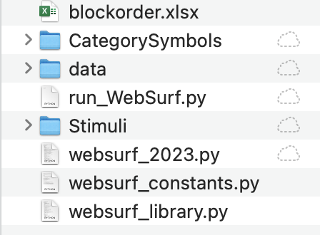

**Things needs to be changed:**

1. File paths in “blockorder.xlsx”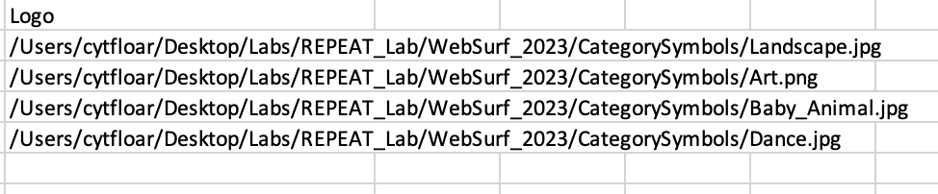
2. File paths in “websurf_constants.py”:

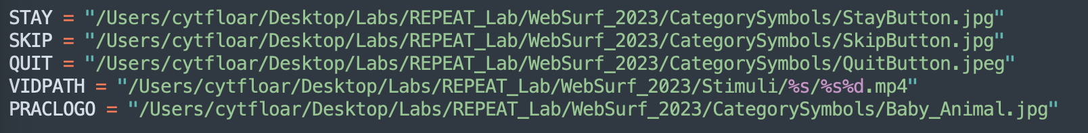

**To run the task, open PsychoPy Coder and drag “run_WebSurf.py” in the window.**

**And hit RUN.**

